ROTARY SAVING LIVES WITH SHELTERBOX
13 April 2021
Salisbury Rotary Club welcomed Howard Matthews as its guest Zoom meeting speaker – Howard being the Wessex Rotary District Co-ordinator for ShelterBox.
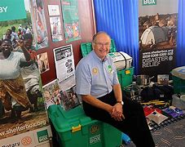
ShelterBox is an international disaster relief charity established in 2000 in Helston, Cornwall, that provides emergency shelter and other aid items to families around the world who have lost their homes to disaster or conflict and gives support to help them in rebuilding their lives.
And, right now, more than 104 million people around the world have been made homeless by disaster and conflict.
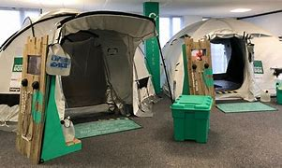
ShelterBox Response Teams distribute aid on the ground, working closely with local organisations, local and international aid agencies an Rotary Clubs worldwide.
Each disaster is different, and so is every community, so Shelterbox do not believe that one size fits all, and therefore their trained Response Teams spend time talking to affected families to make sure the right support is given in the right place at the right time.
This can range from padded tents that can safely accommodate a stove, to medium-sized tents that fit in small spaces and ones that can last years if needed, families can feel at home again.
Shelter kits are also available, which include a selection of hardwearing tools and materials that are customised to suit the needs of each community providing the essentials families need to start rebuilding homes straight away, ranging from thermal blankets, solar lights, cooking utensils, water filtration units through to tough tarpaulin and timber to corrugated sheeting and even room dividers.
The versatile tools also help with everything from clearing rubble to building shelters, tending crops, building furniture, cutting firewood and making repairs.

The cost of the items in a Shelterbox varies from time to time, but the average cost is £590 for a family package with a tent and box, but one type of ShelterBox does not fit all and the contents and costs can vary depending on the needs of the families needing help.
If any person or business wishes to help, please contact Salisbury Rotary Club on 01722 326514.

SHELTERBOX FACTFILE
- 177,410 disaster hit people and 35,482 families benefited from Shelterbox in 2020
- 17 Shelterbox deployments in 11 countries
- 30 million aided in the 2010 Haiti earthquake
- support given to 300 disasters in 97 countries helping 2 million people since 2000
- Rotary provides one third of total Shelterbox funding
- Salisbury Rotary has provided over £30,000 since 2006

-------------------------------------------------ENDS ----------------------------------------------------------

